Sanskriti Patham – Extended Project Documentation

1. Project Title
Sanskriti Patham – Reviving Hindu Culture Through Digital Learning

2. Introduction
In the rapidly evolving modern world, children and youth are increasingly losing touch with the roots of India’s cultural and spiritual heritage. The traditional values, stories, and wisdom that once shaped our way of life are slowly fading in today’s fast-paced digital environment.
Sanskriti Patham seeks to revive this connection by creating a digital learning space that nurtures awareness, respect, and pride in Hindu culture. The initiative promotes holistic development through stories, values, and teachings that inspire compassion, discipline, gratitude, and respect for all beings.

This project is not just about education — it’s about cultural continuity, moral growth, and community awareness. It encourages young minds to explore the timeless principles of Sanātana Dharma in a way that harmonizes with modern learning methods and technology.

3. Project Objectives

Cultural Awareness: To help children and youth understand the significance of Hindu traditions, festivals, and teachings as part of India’s living heritage.

Value-Based Learning: To reintroduce age-old moral and ethical lessons through interactive stories, slokas, and folk wisdom that promote kindness, truth, and self-discipline.

Integration into Daily Life: To inspire schools and communities to include cultural reflections, prayers, and discussions that foster a sense of identity and belonging.

Preservation of Heritage: To safeguard and digitize traditional knowledge — including scriptures, songs, and rituals — ensuring that future generations can access and appreciate them.

Social Unity: To promote understanding and respect for diverse traditions within Hinduism, encouraging harmony and inclusivity among different communities.

4. Target Audience

Primary: School-going children and youth (ages 6–18) who are in their formative years of learning and character building.

Secondary: Educators, cultural organizations, and community leaders who play a role in shaping educational and moral frameworks
Tertiary: Parents, families, and lifelong learners who wish to reconnect with the values and teachings of Hindu culture and pass them forward.
• Promote awareness of Hindu culture and values.
• Provide meaningful cultural education through stories, slokas, and songs.
• Integrate cultural learning into school prayers and daily lessons.
• Digitally preserve ancient knowledge.

4. Target Audience
Primary: Students (Ages 6–18)
Secondary: Teachers & Schools
Tertiary: Parents & Cultural Learners

5. Features
5.1 Educational Content

1. Abstract
Sanskriti Patham is a digital platform designed to preserve and promote Indian cultural heritage, spirituality, and education through Sanātana Dharma. It offers immersive, multimedia-rich content on scriptures, traditions, and practices, targeting users from children to scholars. Key features include educational materials, interactive modules, and community forums, supported by cross-platform accessibility. The project addresses the decline in cultural awareness by leveraging technology for global reach. Developed using modern web and mobile frameworks, it aims for scalability, security, and sustainability. This documentation outlines the project's design, implementation, and future potential, demonstrating its role in bridging ancient wisdom with contemporary digital experiences.

2. Introduction
In an era of rapid globalization, traditional knowledge systems like Sanātana Dharma risk dilution due to limited digital accessibility. Sanskriti Patham emerges as an innovative solution, a comprehensive app and web platform that educates users on India's spiritual and cultural legacy. Drawing from scriptures such as the Vedas and Puranas, the platform integrates multimedia, gamification, and community features to engage diverse audiences. Founded on the principles of inclusivity and authenticity, it serves as a virtual repository for learners, devotees, and scholars. This introduction sets the stage for understanding the project's vision, inspired by the need to democratize cultural education in the digital age.

3. Problem Statement
Modern education often overlooks India's rich spiritual and cultural heritage, leading to a generational gap in understanding Sanātana Dharma. Existing platforms lack comprehensive, age-appropriate content, resulting in fragmented learning experiences. Key issues include:
- Inaccessibility of ancient scriptures for non-experts.
- Lack of engaging multimedia for younger audiences.
- Absence of interactive tools to foster cultural awareness.
- Limited community-driven knowledge sharing.
- Challenges in multilingual and cross-platform delivery.
This project addresses these gaps by creating a unified, user-centric platform that preserves tradition while adapting to digital needs.

4. Methodology
Methodology it would describe the research and development approach: Agile methodology for iterative development, user-centered design with feedback loops, and qualitative/quantitative data collection from surveys and beta testing. Tools include React for UI, Firebase for backend, and AI for content personalization. If this is not "Methodology," please clarify for adjustment.

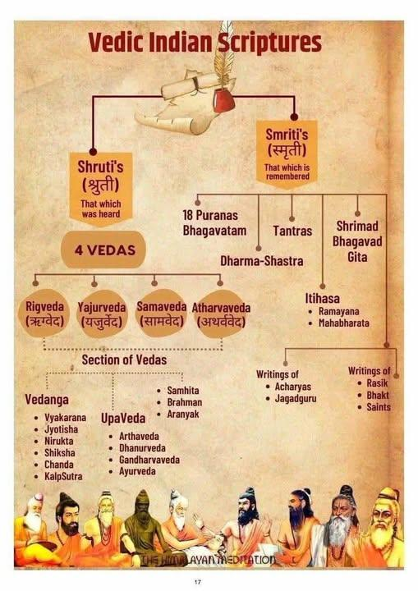
5. Objectives
The primary objectives of Sanskriti Patham are:
- To provide accessible educational content on Sanātana Dharma for all age groups.
- To enhance cultural awareness through multimedia and interactive features.
- To build a global community for knowledge sharing and spiritual growth.
- To ensure universal accessibility across languages, devices, and regions.
- To promote sustainability through monetization and continuous updates.

6. Scope of the Project
The project encompasses:
- In-Scope: Development of 8 core features (Educational Content, Multimedia Learning, etc.), web and mobile apps, multilingual support, and basic community tools.
- Out-of-Scope: Physical merchandise, live events, or integration with non-Indian cultural systems.
- Limitations: Focus on Sanātana Dharma; excludes non-Hindu traditions. Target users: Global, with emphasis on Indian diaspora.
- Deliverables: Functional app, documentation, and marketing materials.

7. Literature Review / Existing System
Existing systems like Khan Academy or Duolingo offer gamified education but lack cultural depth. Platforms such as Gita Press or Vedic apps provide scripture access but are text-heavy and non-interactive. Studies (e.g., UNESCO reports on cultural heritage) highlight the need for digital preservation. Comparative analysis:
- Strengths: Authenticity in apps like Vedanta Society resources.
- Weaknesses: Poor user engagement, limited multimedia, and no community features.
- Gaps: Absence of anime-inspired visuals or gamified spiritual learning. This project builds on these by integrating AI and VR for immersive experiences.

9. System Architecture
The architecture follows a client-server model:
- Frontend: React (web), Flutter (mobile) for responsive UI.
- Backend: Node.js with Express, hosted on AWS.
- Database: MongoDB for NoSQL flexibility (user data, content).
- APIs: RESTful for multimedia integration (e.g., YouTube for videos).
- Security Layer: OAuth for authentication, SSL encryption.
- Scalability: Microservices with Docker for containerization.

10. Security Model
- Authentication: JWT tokens, multi-factor authentication.
- Data Protection: Encryption (AES-256), GDPR compliance.
- Threat Mitigation: Firewalls, regular audits, user data anonymization.
- Privacy: Opt-in for tracking, secure API gateways.

11. Marketing & Monetization Strategy
- Marketing: Social media campaigns, partnerships with temples/schools, SEO for "Sanātana Dharma education."
- Target Reach: 1M users in Year 1 via app stores and influencers.

12. Survival and Sustainability Analysis
- Financial: Break-even in 18 months via subscriptions; low costs with open-source tools.
- Operational: Community contributions reduce content creation load.
- Risks: Cultural controversies; mitigated by expert oversight.
- Sustainability: Open-source code, partnerships for long-term viability.
5.2 Multimedia Learning
Introduction
The Multimedia Learning feature in the Sanātana Project presents India’s culture, heritage, and wisdom in an engaging and modern format. Since many young learners find traditional text-based content difficult to connect with, this feature uses visual and interactive methods such as videos, animations, and illustrated storytelling. This approach makes learning more enjoyable, relatable, and meaningful, helping students easily understand and appreciate the depth of Sanātana Dharma while maintaining their cultural interest and identity.

This component presents cultural stories and moral values through fun and colorful animated videos designed for children. The cartoons use simple language, friendly characters, and short storytelling formats to teach lessons such as honesty, kindness, respect, courage, and compassion. By showing values through relatable scenes and positive role models, children can easily understand and remember them. This approach makes learning enjoyable while helping young learners develop a strong foundation in cultural values and good behavior.

This feature includes educational videos, animated story-based cartoons for children, and anime/manga-inspired visual storytelling aimed at youth and young adults. These media formats help reinterpret ancient scriptures, historical events, festivals, rituals, and moral values in a manner that feels relatable and emotionally compelling. Complex philosophical ideas and spiritual concepts are simplified through narration, characterization, visual symbolism, and guided storytelling, helping learners absorb knowledge naturally rather than memorizing it mechanically.

By adopting multimedia formats familiar to modern audiences, we open the door for learners to connect with Sanātana Dharma not just intellectually, but also emotionally and culturally. This approach bridges the gap between tradition and contemporary digital expression, nurturing pride in cultural identity and encouraging a deeper appreciation for India’s timeless spiritual heritage.

Objectives
. Enhance Engagement:
To make cultural and spiritual learning more interesting and enjoyable by using visually rich and interactive content.
. Simplify Complex Concepts:
To present historical events, rituals, and philosophical ideas in an easy-to-understand format suitable for all age groups.
. Promote Cultural Connection:
To help children and youth emotionally connect with the values and heritage of Sanātana Dharma.
. Encourage Interactive Learning:
To shift from passive reading-based learning to active participation through storytelling, animation, and visual explanations.
. Bridge Tradition with Modern Media:
To use familiar digital formats such as videos, cartoons, and anime-style art to present ancient knowledge in a relatable way.

Manga Feature
- What is a “Manga Feature”
The term "manga feature" can mean different things depending on the context. Usu
Refers to:
- A digital manga platform feature (like manga reading, creation, AI manga generation, translation, etc.).
- Or a manga-based project — for example, an app or website promoting manga reading or production.
Factor | Details
Global Market Size (2025) | ~$25 Billion USD
Fastest Growing Market | India (due to anime streaming & youth fan culture)
Top Countries | Japan, USA, South Korea, France, India
Digital Growth Rate | +12%–15% per year
Popular Manga / Webtoon Apps | Manga Plus, Webtoon, Crunchyroll Manga, Tapas
Main Audience Age Group | 13–35 years

2. Probability Summary
Type of Manga Project | Success Probability | Failure Probability
Manga Reading/Publishing Platform | 0.45 (45%) | 0.55 (55%)
AI Manga Creation/Generation Tool | 0.70 (70%) | 0.30 (30%)
Manga Learning or Cultural App (like “Sanskriti Patham” + manga storytelling) | 0.60 (60%) | 0.40 (40%)

3. Success Rate of Manga Features / Startups
If you are building a manga reading or publishing platform:
- Success Rate: Around 40–60% if marketing and community building are done right.
- Failure Rate: Around 40–60%, mainly due to:
  - Poor marketing
  - Copyright issues
  - Low user engagement
  - Lack of consistent updates

If you are building an AI manga creation or manga translation tool:
- Success Rate: 65–75%, because:
  - AI manga and translation tools are trending.
  - Demand for easy creation and multilingual manga is very high.
- Failure Rate: 25–35% (mainly if product quality or UX is poor).

4. Key Factors That Increase Success
- Strong Community Engagement — users want interaction and story-sharing.
- Good Marketing — use anime/manga influencers, Discord, Reddit, Instagram.
- Unique Concept — mix cultural themes (like Hindu mythology, Sanskrit manga).
- Mobile Optimization — most readers use smartphones.
- Frequent Updates — new chapters, new artists, events

Content Development Workflow
- Topic Selection & Research
  - Choose stories, festivals, rituals, or moral teachings.
  - Verify information from credible cultural and scriptural sources.
- Script Writing & Storyboarding
  - Write child-friendly or youth-appropriate scripts.
  - Create visual storyboards to plan scenes.
- Character & Scene Design
  - Design characters inspired by traditional aesthetics with a modern appeal.
- Animation & Voiceover Production
  - Animate characters and environments.
  - Record narration and add background music.
- Editing & Post-Production
  - Add subtitles, transitions, effects, and color corrections.
- Publishing & Feedback Collection
  - Upload to app/website.
  - Track user engagement and refine future content.

User Target Groups
This feature is designed for a wide audience:
- Children (5–13 years): Animated stories and value-based learning.
- Teenagers and Youth (13–25 years): Anime/manga-style mythological storytelling.
- Parents & Educators: Tools to teach cultural values in a relatable manner.
- General Learners: Anyone interested in exploring Indian traditions.

Accessibility & Language Support
To ensure inclusive learning:
- Content will be available in multiple regional languages.
- Subtitles and clean audio narration will be provided.
- UI font sizes and icons will be child-friendly.
- Color themes will be safe for children’s visual comfort.

Team / Domain | Technologies / Tools | Purpose / Usage
AI / Content Intelligence Team | - Python (TensorFlow / PyTorch) - NLP Models (GPT-based or IndicBERT) - Speech-to-Text / Text-to-Speech (Google TTS, Azure TTS) - Recommendation System (LightFM / Scikit-learn) | - Generates simplified explanations and summaries. - Helps in auto narrations, subtitles, and content recommendation for learners.
Java Backend Development Team | - Java (Spring Boot / Spring MVC) - REST APIs / GraphQL - Hibernate / JPA - MySQL / MongoDB - JWT Authentication | - Handles user accounts, roles, and permissions. - Manages video metadata, learning progress, and content categories. - Ensures secure backend communication.
DevOps & Cloud Deployment Team | - Docker & Kubernetes - GitHub / GitLab CI-CD Pipelines - AWS / Azure / GCP (EC2, S3, Cloud Storage) - NGINX / Apache - Monitoring: Prometheus + Grafana | - Automates deployment and scaling of services. - Ensures stable hosting and streaming of multimedia content. - Manages version control, security, and uptime.
UI/UX & Frontend Development Team | - Figma / Adobe XD (Design) - React.js or Angular (Web App) - Flutter / React Native (Mobile App) - Tailwind CSS / Bootstrap - Video Player Libraries (ReactPlayer, MediaPipe) | - Designs smooth, modern, and kid-friendly interface layouts. - Develops responsive web and mobile applications. - Integrates video/animation playback modules.

5.3 Culturals and Traditional Awareness

1. Abstract
India, the cradle of one of the world’s oldest civilizations, is a land where spirituality and celebration walk hand in hand. Its festivals are not just bursts of color and sound, but deep expressions of faith, philosophy, and timeless cultural memory. Whether it is the warm glow of Diwali lamps, the playful colors of Holi, or the devotion of Navaratri, each celebration carries meaning that binds people to nature, divinity, and each other.
This project, “Festivals of India: A Journey through Traditions, Spirituality, and the Guardians of Dharma,” explores the significance, rituals, and regional diversity of Indian festivals. It also highlights the Sanatana warriors, saints, and protectors of Dharma who preserved these traditions throughout history. By documenting customs, practices, and local variations, the project aims to show how festivals act as living expressions of India’s eternal values: truth, compassion, righteousness, and unity in diversity.

2. Introduction
India is a land where spirituality runs as deep as the roots of its ancient banyan trees. Its festivals shine as bright markers of devotion, gratitude, and unity. Every celebration — from the flickering lights of Diwali to the rhythmic beats of Bihu — tells a story woven from faith, culture, and community.
This project explores the origins, rituals, and regional styles of Indian festivals while spotlighting the Sanatana warriors, saints, and guardians of Dharma who protected these traditions across generations. Each festival is more than a ritual; it is a living expression of India’s eternal values: truth, righteousness, compassion, and unity amid diversity.

3. Problem Statement
While India’s festivals are powerful expressions of its spiritual and cultural identity, today’s fast-paced world often reduces them to commercial or social events. Their deeper meaning — rooted in Dharma, gratitude to nature, and community bonding — is fading or misunderstood.
The lives and contributions of Sanatana warriors, saints, and protectors of Dharma, who safeguarded these traditions through centuries of challenges, are rarely included in mainstream study materials. This creates a gap in understanding how festivals connect to India’s spiritual framework, ethical teachings, and national identity.

4. Scope of the Project
The project aims to explore, document, and digitally preserve the diverse range of Hindu festivals celebrated across India, highlighting their cultural, spiritual, social, and regional significance. It will cover the origins, rituals, historical backgrounds, and modern-day relevance of each festival. The documentation will serve as an educational and cultural resource for students, researchers, and general audiences interested in understanding the depth of Hindu traditions.

5. Objectives
• To document origins, meaning, and festival celebrations.
• To study regional variations in rituals and customs.
• To highlight underlying cultural and philosophical values.
• To introduce contributions of Sanatana saints and Dharma protectors.
• To promote awareness of India’s unity in diversity.

6. Technology Used

6.1 Frontend Technologies
• HTML5 – Structure and layout
• CSS3 – Styling and responsiveness
• JavaScript (ES6) – Dynamic interactions
• Bootstrap / Tailwind CSS – UI components and layouts
• React.js (Optional) – Component-based UI
• Canva / Figma – Design, mockups, illustrations

6.2 Backend Technologies
• Node.js (Express) – Server-side scripting
• Python (Flask / Django) – Dynamic rendering
• MongoDB / MySQL – Database storage
• REST API – Data communication
• Firebase – Authentication and cloud hosting (optional)
7. Expected Outcomes
• Comprehensive reference material on festivals.
• Greater understanding of India’s spiritual and cultural fabric.
• Preservation of traditional knowledge.
• Inspiration from warriors and saints to uphold universal values.

8. References
• Vedas, Puranas, and Itihasas
• Ministry of Culture, Government of India
• Books on Indian spirituality and history
• Cultural research journals and scholarly papers

5.4 Spiritual Music & Chanting

1.Project Title - Spiritual Music & Chanting – Learn, Listen, and Meditate

2.Histroy of Spiritual Music & Chanting:
Spiritual music and chanting have their origins in ancient India, particularly during the Vedic period. In this era, sages recited mantras from the Vedas as a way to connect with higher consciousness and divine energy. The Sama Veda introduced melody and rhythm to these chants, forming the foundation of Indian classical music.
Over time, chanting evolved into forms such as bhajans, kirtans, and slokas, which were sung in temples and households as expressions of devotion. The Bhakti Movement further broadened this tradition. Saints like Tulsidas, Meera Bai, and Purandaradasa composed devotional songs in regional languages, making spiritual practice accessible and meaningful to common people.
In the modern era, spiritual music has continued to grow and adapt, blending with contemporary instruments, global musical styles, and digital media. Today, mantras and devotional songs are shared worldwide, supporting practices like meditation, mindfulness, emotional healing, and communal worship.

Objectives
To spread awareness of Sanatana Dharma through spiritual music and chanting.
To help people learn and correctly practice slokas, bhajans, and mantras.
To create a peaceful and devotional atmosphere using sacred sound and rhythm.
To preserve ancient traditions using modern tools and technology.

5. Curate Content by Category

Devotional content is organized into three primary forms for easy learning and engagement:

Bhajans: Melodic devotional songs expressing love and devotion (e.g., “Raghupati Raghava Raja Ram”).

Slokas: Sanskrit verses recited from sacred scriptures (e.g., Bhagavad Gita, Vishnu Sahasranama).

Mantras: Repetitive sacred sounds or syllables used for meditation and spiritual focus (e.g., “Om Namah Shivaya”).

6. Cultural and Traditional Aspects of Spiritual Music & Chanting

Spiritual music and chanting form a significant part of cultural identity and heritage. In India, bhajans, mantras, and slokas are passed down across generations, performed during festivals, temple rituals, and daily prayers. These chants preserve sacred stories, values, and teachings of Sanatana Dharma. Similar traditions exist globally—such as Gregorian chants in Christian monasteries and Buddhist mantras in Himalayan temples—showing how music universally connects the human soul with the divine.

7. Categorized Devotional Content

The learning content is structured according to age and understanding levels:
Category | Examples | Additional Support
School Level | Saraswati Vandana, Gayatri Mantra, Guru Stotram | Audio, Sanskrit text, English transliteration, meaning
College Level | Vishnu Sahasranama excerpts, Shiva Panchakshari Stotra | Guided recitation and deep meaning explanation
Adult Level | Bhagavad Gita slokas, Lalitha Sahasranamam, Upanishads | Advanced chanting practice with detailed commentary

8. Key Features

Audio Library: Curated chants, bhajans, and mantras with easy playback.

Learning Mode: Line-by-line pronunciation, meaning, and phonetic support.

Meditation Mode: Timed chanting sessions with calming background ambience.

Favorites & Playlists: Save personal devotional tracks for daily practice.

Offline Access: Download and listen without internet.

Accessibility Support: High-contrast interface, screen reader compatibility, multi-language captions.

9. Audio Pronunciation Guides

Sanskrit syllable and phoneme breakdown

Voice options: Male / Female / Child

Playback speed control: Slow, Medium, Fast

Real-time transliteration overlay synchronized with audio

10. Voice Search Integration & Accessibility Tools

Search by voice: users can speak the name of a sloka or deity (e.g., “Play Gayatri Mantra”).

Speech-to-text engine identifies the query and retrieves the correct chant.

Audio responses guide users, ensuring blind and visually impaired users can navigate independently.

11. Technology Stack
Layer | Technology
Frontend (Mobile App) | React Native / Flutter
Backend Services | Python (FastAPI / Django) or Java (Spring Boot)
Database | Firebase / MongoDB
Audio Processing | Librosa, Pydub, SpeechRecognition
AI Voice Generation | OpenAI TTS / Google Cloud TTS / ElevenLabs
Pronunciation Checking | Speech-to-text + phoneme matching algorithms
Cloud Hosting | AWS / Google Cloud / Firebase
UI/UX Design Tools | Figma

5.5 Historical & Temple Archives Module

1. Executive Summary
The 'Historical & Temple Archives' module is a key component of the Sanātana Dharma web platform, designed to preserve and showcase the heritage of ancient temples, spiritual sites, and cultural monuments. It aims to provide users with authenticated historical information, temple architecture insights, stories, legends, and virtual archives, combining technology with cultural preservation. The platform bridges historical data with digital innovation to help users explore the spiritual geography of India and beyond.

2. Vision & Mission
Vision: To create a globally accessible digital archive of temples and spiritual heritage sites that promotes awareness, learning, and preservation of Sanātana cultural history.
Mission: To document, digitize, and present detailed information on ancient temples, their significance, architecture, and associated legends, making them available to scholars and the public in an interactive web format.

3. Objectives
• Build an authentic, searchable digital repository of temples and heritage sites.
• Provide historical, architectural, and cultural details supported by verified sources.
• Integrate interactive maps and image galleries for temple locations.
• Enable virtual learning through stories and legends connected to each temple.

4. Core Features – Historical & Temple Archives
• Database of ancient temples, shrines, and cultural landmarks with verified historical data.
• Categorization based on location, deity, era, and architectural style.
• Interactive map view with GPS integration to explore temple locations worldwide.
• High-quality image galleries showcasing temple architecture and sculptures.
• Legends, stories, and rituals associated with each temple documented in narrative format.
• Option for scholars to contribute verified research papers and findings.

5. Market Analysis & Competitors
While several independent heritage and travel websites exist, few offer a comprehensive digital archive focused exclusively on spiritual and temple history. Key references include: Temples of India (Govt. initiative), mytempletrips.com, and ISKCON heritage databases. The proposed module differentiates itself by offering authenticated data, cultural storytelling, and integration with educational and devotional learning modules within the Sanātana Dharma platform.

6. Target Audience
• Historians, researchers, and archaeologists studying ancient Indian architecture and culture.
• Devotees and pilgrims seeking authentic information on temples and rituals.
• Students and cultural enthusiasts learning about India's heritage and Sanātana history.
• Global audiences interested in Indian civilization and temple architecture.

7. Detailed Technical Implementation
Frontend: React.js framework with Mapbox and Leaflet.js integration for interactive maps.
Backend: Node.js and Express.js REST APIs managing temple data, media, and contributor inputs.
Database: MongoDB Atlas for storing temple records, historical facts, and user-generated content.
Media Management: AWS S3 bucket for high-resolution image and video storage.
Authentication: JWT-based authentication and role-based access (Admin, Contributor, Public User).
Content Verification: Multi-tier moderation workflow ensuring historical accuracy and quality.
Deployment: AWS EC2 instances with CloudFront CDN for fast global delivery.

8. Technology Stack
• Frontend: React.js, Tailwind CSS, Leaflet.js, Mapbox API
• Backend: Node.js, Express.js
• Database: MongoDB Atlas
• Media Storage: AWS S3
• Authentication: JWT + OAuth
• Hosting: AWS / Vercel
• Analytics: Google Analytics, Mixpanel

9. Monetization & Sustainability Plan
• Freemium access to general temple information.
• Partnerships with tourism boards and cultural ministries.
• Sponsored listings and advertisements for heritage tours and educational institutions.
• Donations and cultural sponsorships.

10. Future Expansion
The next phase includes implementing virtual reality temple tours, AI-based historical analysis, and user-contributed photo archives. Integration with the Educational Content and Multimedia modules will provide a unified cultural learning experience.

5.6 Interactive Learning Modules

1. Introduction
The Interactive Learning Modules are designed to make cultural, historical, and spiritual education engaging, enjoyable, and practical. Instead of relying on traditional theoretical methods, these modules use interactive, game-based techniques to help users learn progressively and stay motivated.
The ultimate goal is to make learning immersive — encouraging curiosity, participation, and consistent engagement among learners of all ages and backgrounds.

2. Goals and Purpose
- Provide a well-structured platform for cultural and spiritual learning.
- Encourage users to develop a daily habit of learning.
- Create a fun and interactive environment for all age groups.
- Personalize learning based on user age, interests, and knowledge level.

3. User Categories and Personalization
The platform tailors its content and difficulty level to different learner groups:
- Kids: Animated stories, voice-guided quizzes, and visual activities.
- Students: Concept-based explanations with short exercises.
- Youth: Thought-provoking insights, storytelling, and community discussions.
- Scholars: In-depth scriptural analysis and comparative studies.
- Devotees: Focus on rituals, temple traditions, and devotional practices.

4. Core Features
4.1 Quizzes and Assessments
- Multiple-choice and true/false questions
- Scenario-based decisions
- Performance scoring and feedback
4.2 Puzzles and Cognitive Activities
- Match-the-pair exercises (e.g., Deity ↔ Temple, Verse ↔ Meaning)
- Crosswords on spiritual terms
- Story arrangement and sequencing games
- Memory games featuring symbols, temples, and festivals
4.3 Gamified Learning Challenges
- “Learn One Shloka Per Day” daily challenge
- Weekly festival-based learning missions
- Earn points through consistent study and practice

5. Progress Tracking System
- Automatically tracks each learner’s history and performance
- Displays progress using score charts and completion bars
- Includes daily and weekly streak counters for motivation

6. Badge and Reward System
Learners earn digital badges for their achievements, such as:
- Beginner Learner Badge
- Shloka Champion Badge
- Temple Explorer Badge
- Devotional Consistency Badge
These recognitions encourage long-term commitment and a sense of accomplishment.

7. Technical Structure
- Frontend: Web or mobile interface for lessons and quizzes
- Backend: Stores user data, scores, and progress
- Database: Maintains verified content such as scriptures, facts, and puzzles

8. Content Authenticity
All educational material is curated with utmost care and accuracy:
- Verified scriptural sources
- Cross-checked historical references
- Collaboration with scholars for clarity and authenticity

10. Benefits
- Encourages consistent and enjoyable learning
- Makes cultural education interactive and relatable
- Supports moral, emotional, and intellectual growth
- Strengthens cultural identity among younger generations

11. Example Module Workflows
Learn One Shloka a Day
1. Introduction: Meaning and pronunciation explained.
2. Audio Practice: Listen to recitation.
3. Pronunciation Check: Repeat and record.
4. Quiz: Short understanding check.
5. Reflection: Write what was learned.
6. Reward: Gain streaks and badges.
12. UI/UX Overview
Kids: Bright visuals, animated guides, voice narration
Youth: Modern layout, interactive storytelling
Scholars: Text-rich design with commentaries and cross-references
Sample Screens
- Home Dashboard: Overview of progress and modules
- Learning Module Page: Lessons and quizzes
- Progress Tracker: Badges, streaks, and points
- Profile Page: Personal details and learning stats

13. Assessment & Scoring
- Continuous Learning Points (CLP): Daily logins and activity
- Knowledge Points (KP): Earned from quizzes and tasks
- Streak Rewards: Bonus for consistency
Badge Levels
100 KP: Beginner
300 KP: Seeker
700 KP: Knowledge Bearer
1500 KP: Acharya

14. Data Flow Overview
User → Module Selection → Learning Content → Quiz/Puzzle → Evaluation → Reward → Progress Tracking → Dashboard Update

15. Future Enhancements
- Voice-based chanting recognition
- AR-enabled temple tours
- Festival-based seasonal content packs
- Regional and multi-language support

5.7 Sanskriti Patham
(Reviving Hindu Culture Through Digital Learning)

1. Abstract
In the era of globalization and rapid technological advancement, many young learners are becoming disconnected from India’s traditional roots and cultural wisdom. Sanskriti Patham aims to bridge this gap through a modern digital learning platform that revives Hindu culture, values, and traditions in an engaging, interactive, and child-friendly manner. The platform offers gamified learning, comics, slokas, and storytelling modules that blend ancient teachings with modern educational technology. With universal accessibility and multilingual support, Sanskriti Patham ensures that cultural education is available to all learners across diverse backgrounds.

2. Introduction
Modern education often emphasizes academics and technology while neglecting moral and cultural values. Sanskriti Patham is designed to reintroduce these cultural elements using a digital medium accessible to students, parents, and schools. The platform integrates slokas, stories, festivals, and teachings from Hindu scriptures into structured, interactive modules that make learning fun and meaningful. By using digital storytelling and gamification, the project promotes active participation and continuous engagement among learners.

3. Problem Statement
Children in the digital age are heavily influenced by global media and have limited access to structured cultural education. Existing educational platforms focus mainly on academic subjects and test preparation, leaving moral, ethical, and cultural learning unexplored.
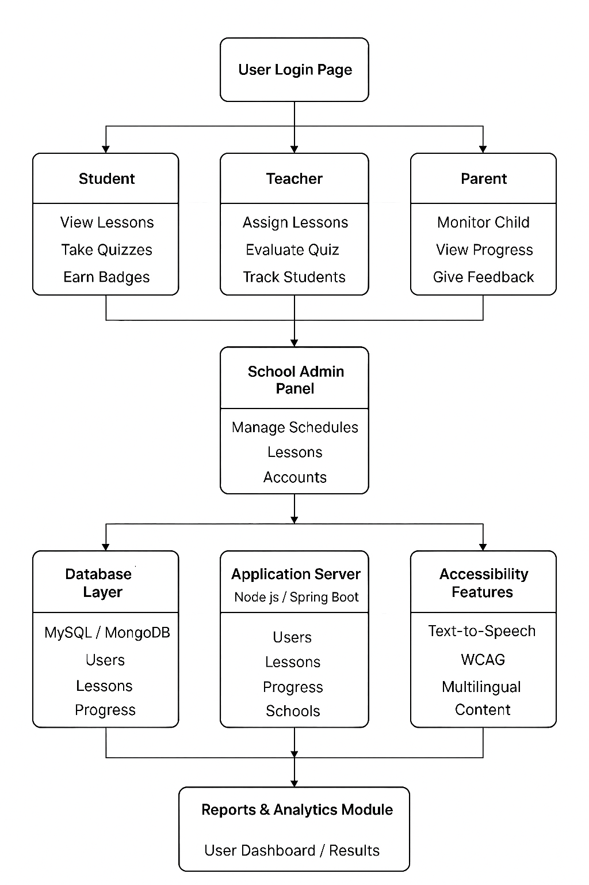
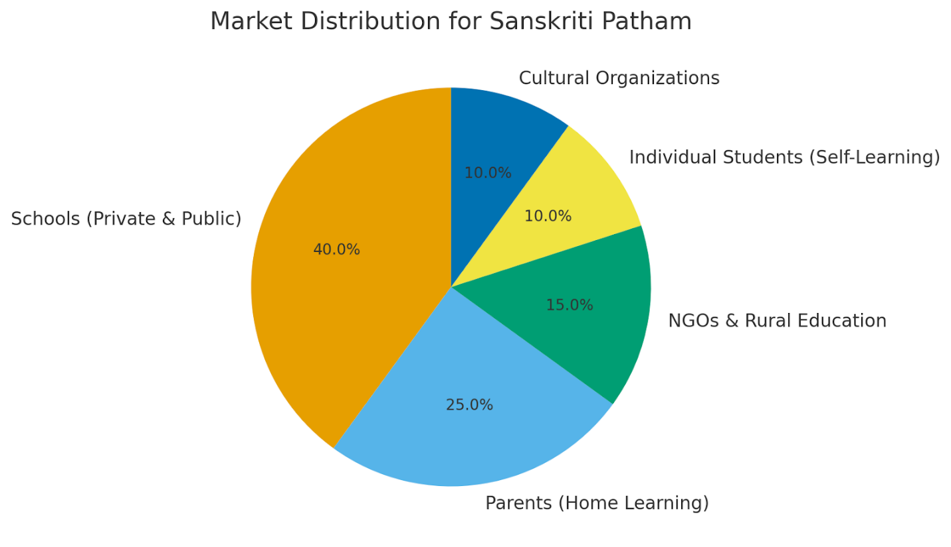

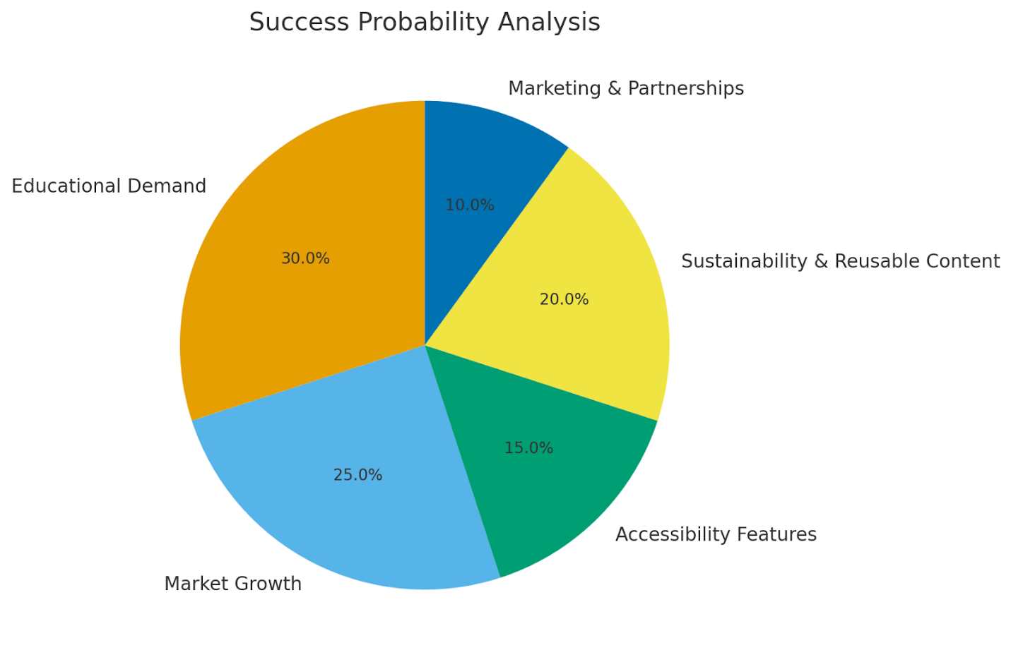

5. Objectives
- To promote awareness and appreciation of Hindu culture and values among students.
- To provide interactive, digital modules for slokas, stories, and festivals.
- To integrate cultural learning into daily school activities and prayers.
- To preserve and digitize ancient cultural knowledge for future generations.
- To ensure universal accessibility for all learners, including differently-abled users.

6. Scope of the Project
The platform serves students aged 6–18 years, teachers, and parents. It can be integrated into school curricula as a cultural education supplement or used independently by families. The system can later expand into mobile applications, regional languages, and AI-driven personalized learning.

7. Literature Review / Existing System
Existing educational platforms like BYJU’S, Vedantu, and Epic! focus mainly on academic learning. Apps like Amar Chitra Katha and YouTube channels provide cultural content but lack structure, interactivity, and tracking. Sanskriti Patham overcomes these limitations by combining curriculum-based cultural education with interactive features such as quizzes, levels, and student dashboards.

8. Proposed System
The proposed system is a web-based and mobile-accessible e-learning platform that delivers structured cultural lessons, daily slokas, and festival-based activities. It includes modules for students, parents, teachers, and school administrators. Each user type has specific permissions and dashboards. The content is gamified, visually rich, and suitable for modern learners. Universal accessibility ensures reach to all students regardless of location, device, or ability.

9. System Architecture
The project follows a 3-tier architecture:
Client Layer: React.js interface (UI/UX, responsive design)
Application Layer: Node.js / Spring Boot API (business logic, authentication)
Database Layer: MySQL / MongoDB (user data, content, progress tracking)
This structure ensures scalability, maintainability, and smooth integration with other educational systems.

10. Functional Modules
- Daily Learning Module – Offers short slokas, stories, and values each day.
- Bhagavad Gita Learning Corner – Simplified verses and moral interpretations.
- Cultural Storytelling – Interactive stories and comics.
- School Prayer Scheduling – Automates daily cultural activities in schools.
- Festival Calendar & Community Space – Celebrates Indian festivals digitally.
- Student Progress Tracking – Monitors growth and achievements.

11. Use Case Diagram / Flow
Student → Access lessons → Take quizzes → Earn badges.
Parent → Monitor child’s progress.
Teacher → Assign and review lessons.
School Admin → Manage school-wide cultural content.
System Admin → Update content and manage user access.

Component | Technology Used
Frontend | React.js, HTML, CSS, Bootstrap
Backend | Node.js / Spring Boot
Database | MySQL / MongoDB
Hosting | AWS / Firebase / Vercel
Authentication | JWT, OAuth 2.0
Accessibility | WCAG 2.1, ARIA standards, Text-to-Speech API

13. Database Design
Main entities include:
- User (student, teacher, parent, admin)
- Lesson (title, category, media links)
- Progress (quiz scores, achievements)
- School (details, assigned modules)
- Festival (date, story, related media)
Relationships ensure easy tracking of learning progress and content delivery.

14. Security Model
- JWT Authentication & Authorization
- Password Hashing (bcrypt)
- Role-Based Access Control
- Cloud Backup (AWS S3 / Firebase)
- Student Data Protection & Privacy Compliance

15. Testing & Evaluation
- Unit Testing: For each module function.
- Integration Testing: Between UI, API, and database.
- Usability Testing: With teachers and students.
- Performance Testing: Load testing for concurrent users.
- Accessibility Testing: Compliance with WCAG 2.1 and screen-reader validation.

16. Universal Accessibility

16.1 Digital Accessibility
- Multi-language content (English, Hindi, Telugu, Tamil, Kannada).
- Screen reader compatibility with ARIA roles.
- Text-to-speech and audio narration.
- High contrast and large-text modes.
- PWA (Progressive Web App) for offline and low-bandwidth users.

16.2 Cultural & Social Accessibility
- Content designed for all learners irrespective of background.
- Gender-neutral avatars and inclusive illustrations.
- Respectful presentation of cultural themes.
- API access for NGOs, rural schools, and community centers.

16.3 Accessibility Tools & Standards
- Follows WCAG 2.1, Section 508, and W3C i18n standards.
- Uses React i18next for language switching.
- Ensures compatibility across devices and browsers.

17. Survival and Sustainability Analysis
- Educational Demand: Increasing adoption of value-based education in schools.
- Reusable Content: Cultural stories and slokas remain timeless.
- E-Learning Growth: India’s market projected at $10B by 2028.
- User Retention: Gamified, child-centric interface ensures daily engagement.

18. Future Enhancements / Scope
- Mobile app for Android/iOS.
- AI-based personalized learning paths.
- AR/VR interactive stories and temple tours.
- Integration with DIKSHA and CBSE moral education programs.

19. Limitations
- Initial dependence on digital devices and internet access.
- Content translation requires manual review for accuracy.
- May need moderation to ensure cultural sensitivity.

5.8 Community & Knowledge Sharing

1. Overview
The Community & Knowledge Sharing module creates an interactive digital space where users can learn, discuss, and share cultural knowledge. It transforms the platform from a one-way learning system into a collaborative environment enriched by real experiences and expert guidance.

2. Objectives
This module promotes meaningful cultural interactions, encourages collaborative learning, and supports long-term engagement through discussions, expert insights, and community contributions. It ensures that knowledge grows dynamically through shared participation.

Main Module Flow Chart
User
|
v
Community Home
|
+--> Discussions Forum
|
+--> Weekly Insights
|
+--> Festival Notifications
|
v
Content View / Interaction
|
v
Moderation & Approval
|
v
Published for All Users

4. Expert Contributions
Trusted scholars, priests, and educators contribute verified explanations, articles, and cultural insights. Their participation ensures authenticity and helps guide learners with reliable information.

5. Weekly Dharmic Insights
Weekly short teachings and cultural reflections keep users connected with dharmic principles. These insights provide simple, meaningful takeaways that encourage consistent learning.

6. Festival Notifications
Users receive timely alerts about upcoming festivals along with explanations, rituals, and cultural significance. This feature helps learners understand and celebrate traditions more deeply.

7. User Content Sharing
Users can share festival photos, artwork, stories, and cultural experiences. Submitted content goes through an approval process to ensure alignment with platform values and authenticity.

8. Community Roles
Role-based access assigns permissions to students, parents, teachers, and scholars. This keeps the environment organized, secure, and guided by credible contributors.

9. System Architecture
The module integrates discussion forums, notifications, and content approval into a smooth workflow. Role-based access control ensures only authorized users publish or moderate content.

10. User Interface & Experience
The interface offers a clean, culturally inspired design with easy navigation across discussions, insights, and notifications. Kids Mode provides a safe and simplified interface for younger learners.

11. Security & Moderation
AI tools and human moderators filter inappropriate or inaccurate content. Reporting features and community guidelines help maintain a respectful and trustworthy space.

12. Benefits
Users learn from a diverse community while engaging deeply with cultural subjects. Experts gain a platform to share knowledge, and the system benefits from stronger engagement and organic growth.

13. Future Enhancements
The module may expand to include live sessions, virtual satsanga rooms, community polls, cultural challenges, and AI-powered question support. These additions aim to increase interactivity and user participation.

14. Importance of the Community Module
This module preserves and nurtures cultural wisdom through active participation. By encouraging ongoing conversations and shared learning, it becomes a living, evolving source of knowledge for all age groups.

15. Role of Collaboration
Collaboration allows users to understand culture through real experiences shared by others. Teachers and scholars guide discussions, helping younger learners develop clarity and confidence.

16. Example Use Cases

Student
Learns sloka meanings through forum discussions and expert replies.
Parent
Shares festival celebrations and learns regional variations from others.
Teacher
Guides students through cultural assignments and discussions.
Scholar
Offers authentic explanations of scriptures and traditions.

17. Future Vision
The module can evolve into a global cultural hub with live talks, VR temple tours, and AI guidance. This vision positions it as a long-term cultural learning ecosystem.

7. Database Design (Conceptual)
Entities include User, Lesson, School, Progress, Quiz, and Festival. Users are linked to learning progress and quizzes. Lessons store slokas, stories, and Gita verses with audio links.
8. Use Case Flow
Student → Views lessons, takes quizzes, earns badges.
Parent → Monitors progress.
Teacher → Assigns lessons.
School Admin → Controls school cultural schedule.
System Admin → Manages platform content.
9. Technology Stack
Frontend: HTML, CSS, Bootstrap, React.js
Backend: Spring Boot / Node.js
Database: MySQL / MongoDB
Hosting: AWS / Firebase / Vercel
10. Implementation Timeline
Phase 1 (2 Weeks): UI Design
Phase 2 (3 Weeks): Core Daily Learning
Phase 3 (3 Weeks): Accounts & Dashboards
Phase 4 (2 Weeks): Media & Interaction
Phase 5 (3 Weeks): School Features & Testing
11. Security Model
• JWT Authentication
• Password Hashing
• Role-Based Access
• Secure Cloud Backup
• Student Safe Data Principles
12. Budget Estimate
Development: ₹35,000 – ₹85,000 (if outsourced)
Hosting: ₹600 – ₹2,000/month
Content Production: ₹10,000 – ₹25,000
Self-development reduces cost drastically.
13. Future Scope
• Multi-language content (Telugu, Tamil, Hindi, Kannada)
• AI-based story recommendations
• Mobile App Version

14. Existing Performance
Platform / Site | Focus Area | Limitation | Our Platform/Site
BharatLearn / BYJU’S | Academic learning (K–12 / exams) | Minimal focus on culture or moral education | Culture-first curriculum with slokas, stories, values, plus interactive comics, games, and levels
Epic! (Kids Books App) | Digital storybooks and reading platform for kids | Global stories only; lacks Indian cultural or religious context | Curated Indian cultural stories, slokas, and comics with puzzles, badges, and progress levels
Amar Chitra Katha App | Indian history and mythology comics | Primarily static reading; limited interactivity | Adds structured learning, quizzes, progression, and school-based tracking system
Vedantu / Toppr | Live tutoring and exam preparation | Exam-focused; not cultural or moral learning | Promotes cultural and value-based learning integrated with traditional lessons
YouTube Channels | Informal cultural and devotional videos | Unstructured, no curriculum or tracking | Structured lessons with curriculum flow, quizzes, and progress dashboard
DharmaCentral (ISDS) | Articles and teachings on Sanātana Dharma | Adult-oriented; lacks child engagement tools | Designed for children with comics, games, puzzles, and guided cultural paths
sanatan-dharma.in | Informational blog about Hindu philosophy and rituals | Text-heavy, no interaction or classroom integration | Interactive platform with quizzes, comics, and school-friendly modules
usd.ac.id (Sanata Dharma University) | Educational university website (Indonesia) | Higher education content; not for kids or cultural learning | Targeted K–12 content with bite-sized lessons, visuals, and gamified learning
VidyaLink (Concept Project) | Rural digital education for school students | Focused on academics and digital equity; not cultural | Dedicated Hindu cultural education with gamified levels, slokas, and festivals
DharmaSutra (Concept Project) | Ancient philosophy and scriptures learning | Text-heavy, philosophical focus; lacks interactivity for children | Uses comics, puzzles, and games to simplify cultural learning for young audiences

15. Survival and Sustainability Analysis

1. Educational Demand:
Schools increasingly look for value-based learning modules beyond textbooks. This makes Sanskriti Patham a potential partner for educational institutions.

2. Content Longevity:
Cultural and traditional content never becomes outdated; it only needs modern representation. Once the comics, stories, and games are created, they can be reused for years.

3. Digital Growth:
India’s e-learning market is projected to reach $10 billion by 2028, especially for child-oriented platforms. Sanskriti Patham fits perfectly into this growing trend.

4. Engagement Retention:
By combining learning + play + levels, the app keeps children returning regularly, ensuring high user retention and organic growth.

5. Monetization Possibilities:
• Freemium model – Free basic content, premium subscription for more levels/games
• School partnerships – Paid school access portals
• Ads / sponsorships from educational brands
• Merchandise (books, comics, puzzles)

6. Long-Term Vision:
As cultural awareness rises and schools integrate value education, Sanskriti Patham can scale into a national cultural e-learning brand.
16.Sanskriti Patham vs Other Platforms – A Comparative Analysis

Aspect | Other Platforms (e.g., BYJU’S, Epic!, Amar Chitra Katha, etc.) | Sanskriti Patham
Focus Area | Mostly academic learning or static reading platforms | Combines academics with Indian culture, stories, and values
Cultural Integration | Minimal or limited Indian cultural content | Deeply rooted in Indian traditions, festivals, slokas, and values
Interactivity | Mostly static content or videos | Highly interactive with games, quizzes, puzzles, and comics
Learning Structure | Unstructured or exam-focused | Structured curriculum with levels, goals, and progress tracking
Target Audience | Mainly academic learners or adults | Specially designed for K–12 children
Engagement Level | Low engagement beyond reading or watching | Gamified and story-driven learning experience
Moral & Value Education | Often ignored or secondary | Core part of the platform’s curriculum
Accessibility for Schools | Limited classroom integration | School-friendly modules and dashboards for teachers
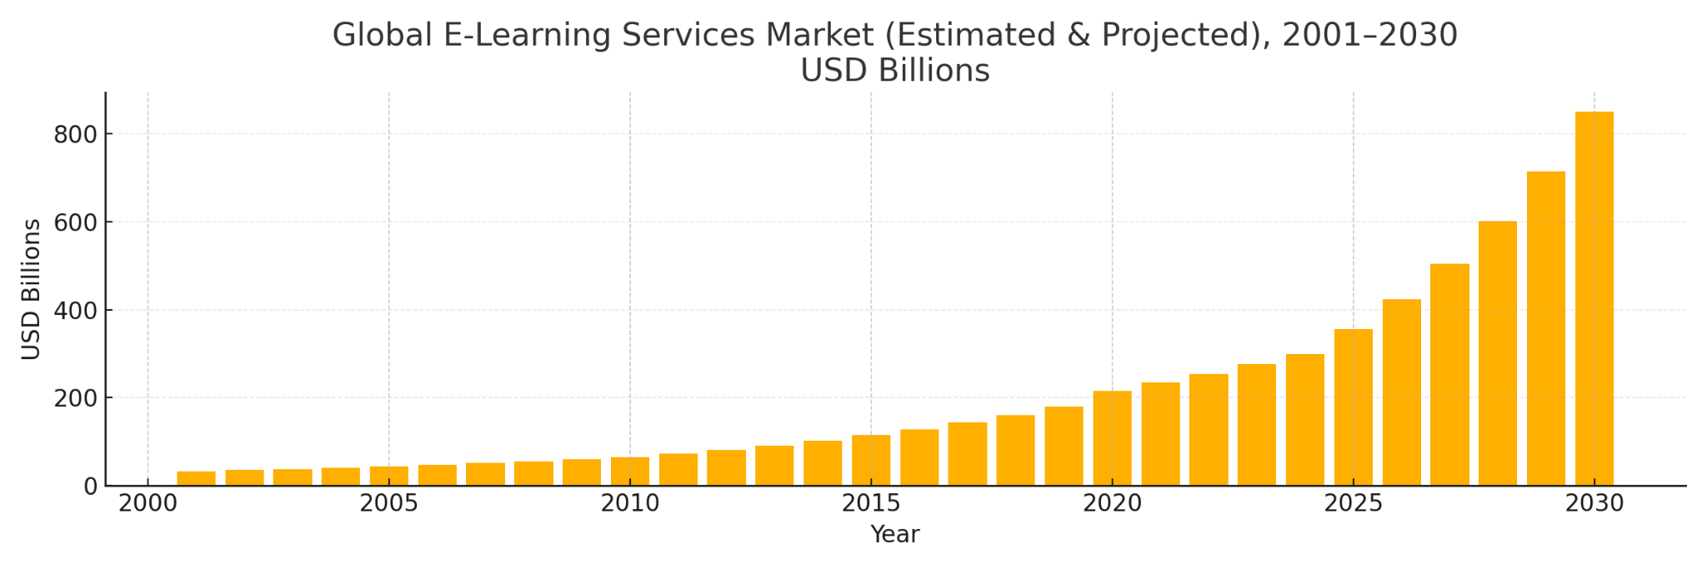

16. Conclusion
Sanskriti Patham blends the wisdom of ancient Hindu culture with the excitement of modern learning.
By introducing comics, puzzles, and games, the platform transforms cultural education into an interactive journey rather than just reading.

Its strong educational value, unique niche, and sustainable content ensure that the project can not only survive but thrive in the competitive digital education ecosystem — becoming a lasting initiative to revive and celebrate Indian heritage through technology.

